

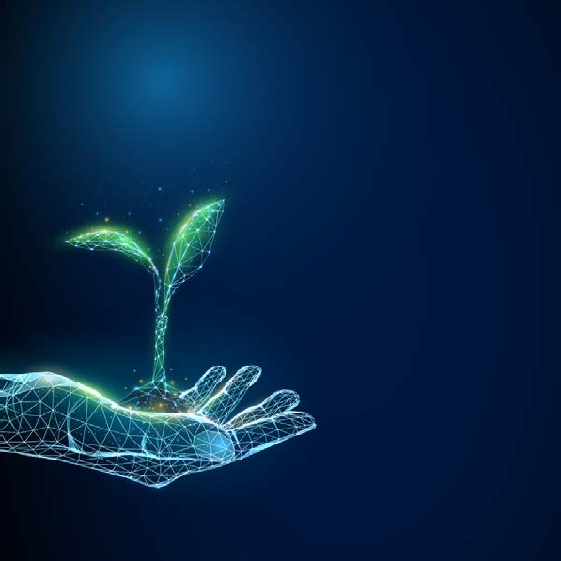










3rd International Symposium on Digital Technologies in Agriculture
ISDTA 2026
& 33d Satellite Workshop -
Digital Agriculture in Rural Area
DIGITAGRA 2026

OSIJEK, CROATIA
1 – 4 December 2026 Faculty of Agrobiotechnical Sciences Osijek
Campus, Osijek

Organizers

- Faculty of Agrobiotechnical Sciences, Josip Juraj Strossmayer University of Osijek
- Agricultural Institute Osijek, Croatia
- Balkan Environmental Association (B.E.N.A.)
- Croatian Agency for Agriculture and Food, Osijek, Croatia
- Faculty of Food Tecnology Osijek, Croatia
- Faculty of Electrical Engineering, Computer Science and Information Technology Osijek
- University of Zagreb Faculty of Agriculture Zagreb, Croatia
- Faculty of Agricultural Sciences and Food, Skopje, North Macedonia
- Josip Juraj Strossmayer University of Osijek, Croatia
- NOVA School of Science and Technology, NOVA University Lisbon, Portugal
- Department of Agricultural and Food Sciences, Alma Mater Studiorum - Università di Bologna, Italy
- Technical University of Varna, Varna, Bulgaria
- Faculty of Information and Communication Technologies, University “St. Kliment Ohridski” Bitola, North Macedonia
- Faculty of Science and Technology, Jan Dlugosz University in Czestochowa, Poland
- University of Life Sciences ‘’King Mihai I’’ from Timişoara, Romania
- School of Applied Economics and Social Science, Agricultural University of Athens
- Faculty of Agricultural and Food Sciences and Environmental Management, Debrecen, University of Debrecen, Hungary
- Faculty of Agriculture and Food Technology, University of Mostar, Mostar, Bosnia and Herzegovina
- School of Agricultural and Environmental Sciences, University of the Azores, University of the Azores, Angra do Heroísmo, Portugal
- Agricultural Institute of Slovenia, Ljubljana, Slovenia
- Van Hall Larenstein University of Applied Sciences (VHL UAS), Leeuwarden and Velp, the Netherlands

Organizing Committee:
Chairman
Tomislav Vinković, Croatia

Members
Zvonimir Zdunić, Croatia Mariana Golumbeanu, Romania Hrvoje Hefer, Croatia
Stela Jokić, Croatia
Tomislav Matić, Croatia
Aleksandar Mešić, Croatia
Mile Markoski, North Macedonia
Drago Šubarić, Croatia
Marin Kovačić, Croatia

Fernando Lidon, Portugal Matija Žulj, Croatia Plamena Yankova, Bulgaria Marcin Sosnowski, Poland
Cosmin Alin Popescu, Romania
Konstantinos Tsimpoukas, Greece
Jurica Primorac, Bosnia and Herzegovina

Secretary
Ivana Varga, Croatia

Scientific Committee
Chairman
Zdenko Lončarić, Croatia

Student Chairman
Marta Doboš, Croatia

Members
- Ivan Plaščak, Faculty of Agrobiotechnical Sciences Osijek, Croatia
- Tomislav Vinković, Faculty of Agrobiotechnical Sciences Osijek, Croatia
- Ružica Lončarić, Faculty of Agrobiotechnical Sciences Osijek, Croatia
- Zvonko Antunović, Faculty of Agrobiotechnical Sciences Osijek, Croatia
- Robert Burns, University of Tennessee Knoxville, Knoxville, Tennessee, United States
- Vladimir Ivezić, Faculty of Agrobiotechnical Sciences Osijek, Croatia
- Vlatko Galić, Agricultural Institute Osijek, Croatia
- Danijel Topić, Faculty of Electrical Engineering, Computer Science and Information Technology Osijek, Croatia
- Krunoslav Aladić, Faculty of Food Technology Osijek, Croatia, Croatia
- Ivana Janeska Stamenkovska, Faculty of Agricultural Sciences and Food, Skopje University „St. Cyril and Methodius“, North Macedonia
- Márk Rékási, Institute for Soil Sciences, Centre for Agricultural Research, HUN-REN, Budapest, Hungary
- Hrvoje Kutnjak, University of Zagreb Faculty of Agriculture Zagreb, Croatia
- Vesna Gantner, Faculty of Agrobiotechnical Sciences Osijek, Croatia
- Tihana Sudarić, Faculty of Agrobiotechnical Sciences Osijek, Croatia
- Zvonimir Zdunić, Agricultural Institute Osijek, Croatia
- Vlado Guberac, Josip Juraj Strossmayer University of Osijek, Croatia
- Fernando Lidon, NOVA School of Science and Technology, NOVA University Lisbon, Portugal
- Manuela Simões, NOVA School of Science and Technology, NOVA University Lisbon, Portugal
- Plamena Yankova, Technical University of Varna, Varna, Bulgaria
- Janusz Kapusniak, Jan Dlugosz University in Czestochowa, Poland
- Renata Barczynska-Felusiak, Jan Dlugosz University in Czestochowa, Poland
- Raul Pascalau, University of Life Sciences ‘’King Mihai I’’ from Timişoara, Romania
- Laura Iosefina Șmuleac, University of Life Sciences ‘’King Mihai I’’ from Timişoara, Romania
- Andreas Drichoutis, School of Applied Economics and Social Science, Agricultural University of Athens
- Carolina Constantin, Romania

- Zaharoula S. Andreopolou, Aristotle University oh Thessaloniki, Greece
- Daniel Rašić, Croatian Agency for Agriculture and Food, Osijek, Croatia
- Erika Kutasy Tünde, Faculty of Agricultural and Food Sciences and Environmental Management, University of Debrecen, Hungary
- Janez Prešern, Agricultural Institute os Slovenia, Slovenia
- Marija Banožić, Faculty of Agriculture and Food Technology, University of Mostar, Mostar, Bosnia and Herzegovina
- Mariana Casari Parreira, School of Agricultural and Environmental Sciences, University of the Azores, University of the Azores, Angra do Heroísmo, Portugal
- Jannet Lavalette, Van Hall Larenstein University of Applied Sciences (VHL UAS), Leeuwarden and Velp, the Netherland

Programme Committee

Chairman
Ivana Varga, Croatia

Members
- Dario Iljkić, Faculty of Agrobiotechnical Sciences Osijek, Osijek, Croatia
- Sanja Jelić Milković, Faculty of Agrobiotechnical Sciences Osijek, Osijek, Croatia
- Đurđica Kovačić, Faculty of Agrobiotechnical Sciences Osijek, Osijek, Croatia
- Monika Tkalec Kojić, Faculty of Agrobiotechnical Sciences Osijek, Osijek, Croatia
- Ivana Varga, Faculty of Agrobiotechnical Sciences Osijek, Osijek, Croatia
- Anamarija Banaj, Faculty of Agrobiotechnical Sciences Osijek, Osijek, Croatia

We are delighted to announce the ISDTA 2026
(33d International Symposium on Digital Technologies in Agriculture) and DIGITAGRA 2026 (3rd Workshop - Digital Agriculture in Rural Area) which will be held on December 2026, Tuesday 1st to Friday 4th 2026
in Osijek, Croatia.

The new Hybrid format of ISDTA 2026 includes face-to-face meetings and other events and option of participating online as well.

The 3rd ISDTA will be organized by the Faculty of Agrobiotechnical Sciences Osijek, Josip Juraj Strossmayer University of Osijek and other partners from Croatia and from across the globe.

ISDTA 2026 Symposium Objectives
The 3rd ISDTA will enhance exchange and dissemination of knowledge and experience, ideas and results and promote internationalization and friendships among researchers and professionals in all research
fields associated with digital technologies in agriculture, with a focus on precision agriculture, agronomist education in digital agriculture, data collection and all the other aspects of digital technologies in agriculture. The major theme of the 3rd ISDTA will be the role of digital technologies in the mitigation of climate change, but still with the digitalization of all segments of agriculture as the basis of the symposium.

ISDTA 2026 Symposium Topics
Data collection, analysis and management Precision crop production
AI, Models and Decision support systems in digital agriculture Digital technologies in agriculture
Digital agroeconomic and marketing Agronomist education in digital agriculture
Project Showcase

Papers not covered directly by the listed themes, and belonging to the field of Digital Technologies in Agriculture will be allotted to one of the listed sections. It is possible a new Symposium Topic will be created based on the topics of submitted papers, in the case enough papers about the new topic are submitted.

DIGITAGRA 2026 - Digital agriculture from a student perspective

Workshop
The main purpose of the 3rd Workshop Digital Agriculture in Rural Area will be:
Student perspective on digital technologies in rural areas
Advantages and disadvantages of using AI on different agricultural entities
Digital technology for detection, evaluation and response to stressful conditions in plant cultivation

Abstract
A one-page abstract in English must be submitted by 15th November 2026
using registration site (https://prijave.dubrovniksun.hr/isdta-digitagra-2026/)
or via email to the scientific committee (isdta26@fazos.hr).

Please, use only the template uploaded on the symposium website

www.ict-agriculture.com.

Deadlines
15th November 2026 – Abstract submission
20th November 2026 – Abstract decision
23th November 2026 – Final program

Registration fees category | EARLY BIRD  (until October 30th) | STANDARD  (after October 30th)
“Onsite” - participant | EUR 200.00 | EUR 250.00
“Online” - participant | EUR 100.00 | EUR 120.00
Student  (bachelor, master, PhD student) | EUR 100.00 | EUR 140.00
Accompanying person | EUR 150.00 | EUR 200.00

Preliminary Programme

Tuesday

1 December 2026
Arrival
Registration // Welcome cocktail reception

Wednesday

2 December 2026
Registration // Opening ceremony
Lectures (Oral presentation, Panel discussion, Project Showcase, Poster presentation)
Gala dinner

Thursday

3 December 2026
Parallel sections
Poster presentation, Project Showcase Workshop – DIGITAGRA 2026 - Digital agriculture from a student perspective

Friday

4 December 2026
Departure

Announcement to all symposium participants

We are pleased to announce that
- Frontiers in Soil Science and
- Frontiers in Agronomy
are official partners of ISDTA & DIGITAGRA.
As part of this partnership, a dedicated Research Topic will be launched around the time of symposium, and all participants are welcome to submit their work to it. The collection will bring the contributions together in one place and amplify the impact of the symposium.

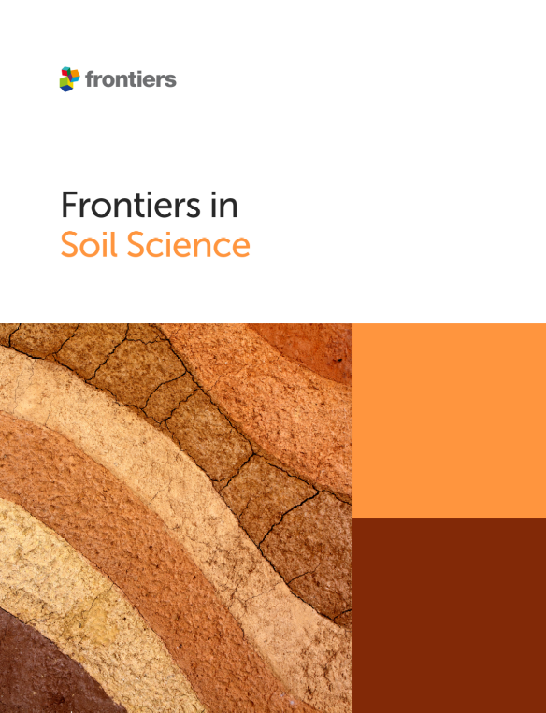
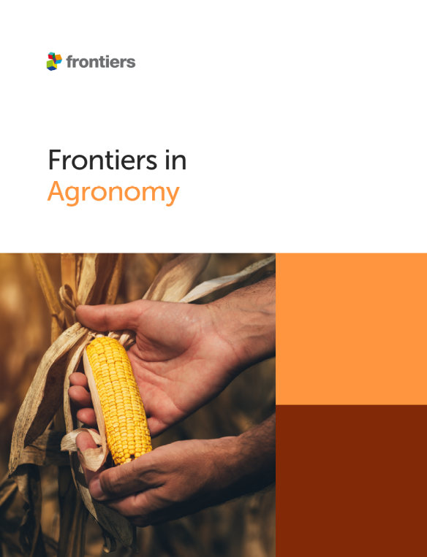


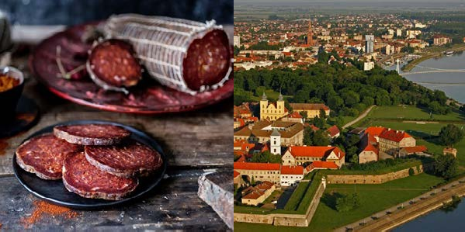

We look forward to welcoming you to Osijek for the 3rd ISDTA 2026

